Reg. No. CODE: SPH2

PRE-PH. D. EXAMINATION, MAY 2023
SUBJECT: BIOTECHNOLOGY
SPECIALIZATION PAPER II
RESEARCH COMMUNICATIONS IN ECOLOGY, EVOLUTION, AND BEHAVIOUR - INSIGHTS TO IMPACTS.
Time: 03 hours Maximum Marks: 50
Student Name: Bramhi Suresh Chougule & Nagtilak Suraj Dilip
Instructions: Make sure you have copies of the following in your hand before you start answering the paper.
- Research paper
- Research article
Answer the questions in the booklet provided to you clearly writing the correct question numbers and sub number formats.

ANSWER THE FOLLOWING QUESTIONS. Each question (Numbered 1-10) carries 5 marks each.
- Identify the cause, verb and effect for the following journal paper titles
  - The influence of interspecific competition and other factors on the distribution of the barnacle Chthamalus stellatus (Connell, Ecology, 1961).
  - Predator identity more than predator richness structures aquatic microbial assemblages in Sarracenia purpurea leaves (Canter et al., Ecology, 2018).
  - ASK family kinases mediate cellular stress and redox signaling to circadian clock (Imamura et al., Proceedings of the National Academy of Sciences, 2018)
  - Polygenic evolution drives species divergence and climate adaptation in corals (Rose et al., Evolution, 2017)
  - Ecological traits interact with landscape context to determine bees’ pesticide risk (Knapp et al, Nature Ecology & Evolution, 2023)

- Examine the titles of journal articles provided below. For each title, decide if you think the goal of the research was to: (mark as a b c d or e as your option for each title indicating the correct question number)
a. describe a cause-and-effect relationship
b. describe a pattern, measurement, or observation in nature
c. describe a scientific model
d. describe a tool or process for scientific research
e. something else

- Two microcephaly-associated novel missense mutations in CASK specifically disrupt the CASK–neurexin interaction (LaConte et al., Human Genetics, 2018)
- Protein measurement with the Folin phenol reagent (Lowry et al., Journal of Biological Chemistry, 1951 )
- The process of natural selection and the formation of new varieties and species (Darwin and Wallace, Zoological Journal of the Linnean Society, 1859 )
- Comparative Anthropology and Rhetorics in Cultures. Reflections on Argumentation Theories and Forms of Life (Balagangadhara, 1989)
- Reconstructing the demographic history of the Himalayan and adjoining populations (Tamang et al., Human Genetics, 2018)

- In 2022, Consentino & Gibbs published a scientific paper (Cosentino, B.J., Gibbs, J.P. Parallel evolution of urban-rural clines in melanism in a widespread mammal. Sci Rep 12, 1752 2022). The authors sources squirrel populations from records and citizen science portals to evaluate melanism as a result of urbanization. They communicated their findings in a scientific journal so that others in the scientific community could know about their claims, evaluate the evidence, repeat the experiments, and use the information to design new experiments.

- The goal of the "Abstract" is to provide a brief summary of the paper. Most abstracts present the research question, the methods used, the results, and the significance of the findings. In your own words, describe the research question for this study.
- The goal of the "Introduction" is to help readers understand why the research question is important. To do this, scientists often briefly summarize what is and is not known about the research question, as well as what they did to address the question. They may also describe the structure of the rest of the paper.
- What argument do the authors make for why their research is important?
- What do the authors say is known and not known about the health of animal in urban areas?
- How do the authors prepare readers for reading the rest of the paper? Consider the entire "Introduction" in your response.

- You will now make a concept map (Connecting the dots like the food web) of the information in the “Introduction.” A concept map is a diagram (not a linear one) that shows the relationships among different concepts. Create your concept map using the following terms as your concepts. Connect related terms with a line and label each line with a brief phrase describing the relationship between the terms.

Urbanization | landcover | Clines
melanism | Squirrels | thermoregulation
Parallel evolution | Isolation by distance | Generalized linear model
- Answer
- What were the controls and experimental manipulations in this experiment? Give specific examples of each.
- What arguments do the authors provide for the following observations
  - the lower mortality of melanic(black) squirrels in urban areas
  - greater abundance of gray squirrels in both urban & rural areas

- Create a diagram or cartoon to illustrate the experimental design described in the above squirrel article. Your illustration can be fairly general but should show how the scientists did the overall experiment. (two examples are given below)
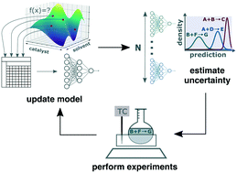
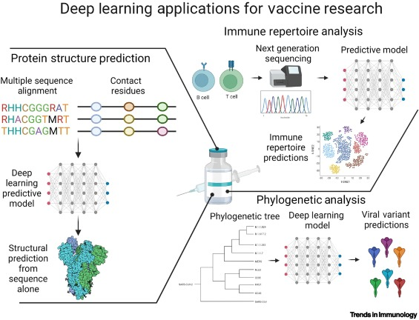

- Arrange these jumbled words in the correct logical order in an algorithm fashion
Make a prediction based on the hypothesis, Analyze the results, ask a question, Report results, perform an experiment to test the prediction, Try again, Hypothesis supported, Make an observation, Form an hypothesis, hypothesis not supported
- Scientific method is used to solve an everyday problem. Identify the observation? Identify hypothesis? Identify prediction? Based on the results of the experiment, is the hypothesis supported? If it is not supported, propose some alternative hypotheses.
  - My oven doesn’t heat chapathi.
  - Why doesn’t my Oven work?
  - There is something wrong with the electrical outlet.
  - If something is wrong with the outlet, then electrical juicer machine should also won’t work when plugged.
  - I plug electrical juicer machine into the outlet.
  - The electrical juicer machine works.

- Read the article “Science Says: Gene editing widely used in range of research,” Write briefly reacting to the ideas in the article and their possible impacts. Your explanations should answer one or more of the following questions:
a. How does the information in the article connect with what you've learned in science course?
b. How does the information in the article relate to you, your community, or society in general?
c. What did you find interesting or surprising about the article?

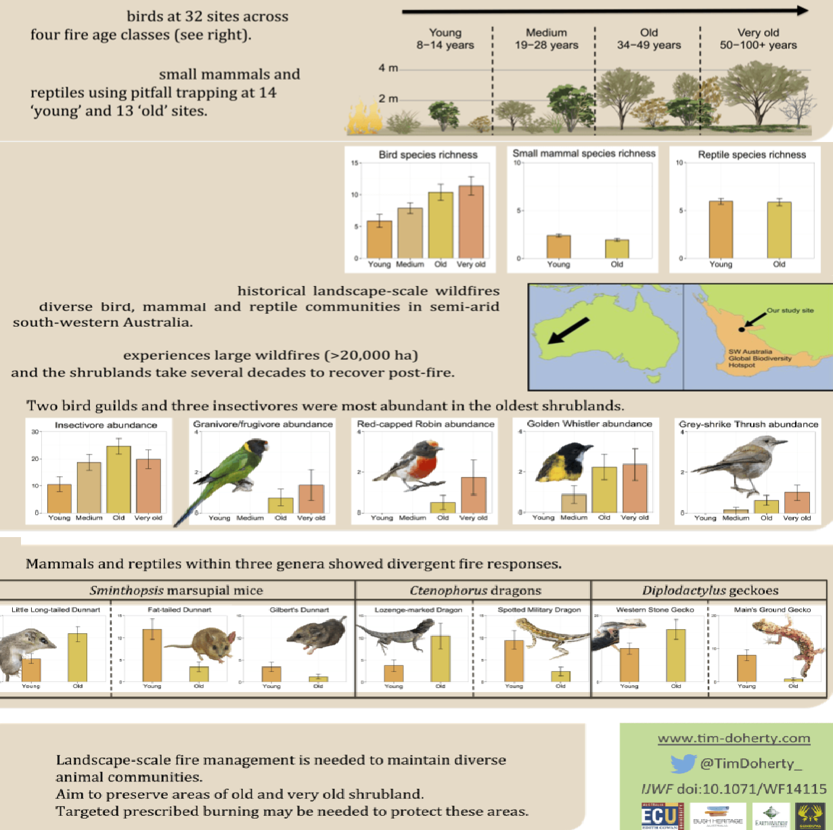
- Write a scientific abstract (background, question, methods, results, implication of the study) of the following award winning (2015) poster of Doherty et al.

